Ethanol Case Study – Evaluating Human Dose-Response of Morbidity and Mortality from Hepatic Disease: Are the Predicted Risks from Low-Dose Linear Extrapolation to Environmentally Relevant Concentrations Biologically Plausible?
(revised 20 April 2011)

Rick Becker¹, Chris Kirman², Sean Hays³

1 American Chemistry Council, Washington, DC
2 Summit Toxicology, L.L.P. Cleveland, OH
3 Summit Toxicology, L.L.P. Allenspark, CO

1. Provide a few sentences summarizing the method illustrated by the case study.
This case study evaluates the dose response of ethanol, a well-studied hepatic toxicant. The purpose for this case study is to explore the question of low-dose linearity of toxicity using the human dose response relationships for ethanol-induced mortality and morbidity (liver cirrhosis). This may prove to be a particularly illustrative example, since human exposures to ethanol occur not only from ingestion of alcoholic beverages, which account for “high doses” in most human epidemiological studies investigating exposures and associated adverse health effects, but also to low doses from inhalation of trace levels from volatilized fuels and from ingestion as a natural constituent of foods (e.g., fruits, breads, etc.). One can use this analysis to probe issues pertaining to linearity / threshold of the dose response at individual and population levels. And since the mode of action of ethanol induced hepatic toxicity is fairly well understood, the case study can be expanded to include a mode of action or adverse outcome pathway analysis.

1. A. Summary of the case study
Low, environmentally relevant, exposures to ethanol are experienced by everyone from ingestion of trace levels of ethanol in common foods (e.g., fruits, juices, breads, etc.). In this case study, quantitative dose-response relationships were defined using published information on the relationship between chronic high levels of ethanol consumption and both the incidence of liver cirrhosis and mortality related to this disease in humans to explore the validity of linear arithmetic extrapolation assumptions for estimating theoretical risks to low dose exposures. Using human dose response data, theoretical risk estimates were calculated for ingestion of ethanol at the low levels of exposure experienced across the entire population due to ethanol’s presence as a component in a normal diet. Three methods for extrapolation were employed: 1) the traditional NOAEL (or BMDL) method with adjustment (“safety” or “uncertainty”) factors; 2) the arithmetic linear, no-threshold conceptual model recommended by the authors of the NRC Science and Decisions report (NRC, 2009) report; and 3) use of the probit model in BMDS for estimating population risks. The results were compared and discussed to shed light on the universality, or lack thereof, of assuming a low-dose arithmetic linear extrapolation model for risk assessment of systemic toxicity at environmentally relevant concentrations.

Table S1. Estimates of population reference values using threshold approach, arithmetic linear extrapolation, and probit/log-probit models of low-dose extrapolation.
Method of Dose-Response Extrapolation | Population Reference Values (PRV) (g/day)ª | Ethanol Ingestion (drink/day) @ the PRV^{c}
Mortality
- Threshold | 2.6 | ¼ drink/day
- Arithmetic Linear | 0.018^{b} | 1/500 drink/day
- Log-Probit model | 1e-3 (male), 9e-12 (female) ^{b} | 1/10,000 drink/day (male)  1/1,000,000,000,000 (female)
Morbidity
- Threshold | 5.5 | ½ drink/day
- Arithmetic Linear | 0.11^{b} | 1/100 drink/day
- Probit model | 0.85^{b} | 1/10 drink/day
a – Results reported as average for male and female unless otherwise noted.
b – population risk of 1e-5
c – assuming the average drink contains 10 g of ethanol. This amount is equal to 10 ounces (300 cc) of regular beer (5% alcohol content); 3-4 ounces of wine (12% alcohol content); or 1 ounce of hard liquor (40% alcohol content, 80 "proof.” http://www.emedicinehealth.com/alcohol_intoxication/article_em.htm

Even individuals who abstain from drinking alcohol are exposed to ethanol because trace levels are natural constituents of many fruits, breads and other foods. One common source of trace levels of ethanol exposure is fruit juices. Typical doses of ethanol from fruit juices have been calculated to be approximately 0.35 grams/day per individual. Ethanol has also been found to be endogenously produced in the human gut via bacterial degradation of carbohydrates, and there is some evidence that ethanol may be produced in normal cells within the body. When these background and endogenous sources are accounted for, the NRC approach of linear extrapolation and setting the “acceptable risk” at 1e-5 would yield a margin of safety of less than 1. In contrast, the human Population Reference Values of 2.6 g/day for mortality and 5.5 g/day for morbidity would predict no individual or population risk for developing ethanol-induced cirrhosis or ethanol-induced mortality from consumption of ethanol as a natural constituent of fruit juices.
Table S2: Calculation of Ethanol Consumption from Fruit Juice
Average Consumption of fruit juice in U.S.ª | 42.8 L/yr
Concentration of ethanol in orange juice (Davis, 1971) | 3 gr/L
Ethanol consumption from fruit juice (42.8 * 3/365=0.35 g/day) | 0.35 g/day
ª http://www.nationmaster.com/graph/foo_fru_jui_con-food-fruit-juice-consumption
Evaluation of the pathogenesis of ethanol-induced cirrhosis using a key events dose response framework, which included consideration of endogenous ethanol exposure, indicated strong support for a threshold dose response in humans.

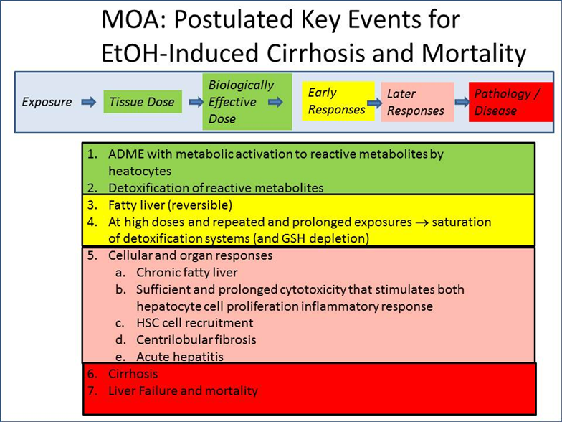

In our opinion, the assumption of low dose arithmetic linear extrapolation for estimating risks of cirrhosis from ethanol ingestion results in estimates of risk that are at odds with epidemiology literature and in contrast to medical opinion. This procedure is at odds with the concept of threshold and falls short of achieving a scientifically reasonable replacement of the threshold-adjustment factor method. While the probit model of BMDS appears to provide a means to readily estimate risk below a human toxicity reference value (e.g., a RfD), the widely disparate calculations of mortality risks indicates further investigation of probit methods is warranted prior to adoption as a preferred method.
Based on this analysis as well as consideration of the theoretical basis of thresholds in biological responses we conclude that a threshold dose of ethanol exists, below which there is essentially no individual or population risk for development of hepatic cirrhosis. Ingestion of low, environmentally relevant levels of ethanol is safe. The threshold dose of ethanol, at or below which there would be no risks of adverse hepatic effects, is not known with certainty, but an educated guess would suggest that this threshold is no less than 30 to 150 mg/kg-day (approximately 2,000 mg/day to 10,000 mg/day for a 70 kg individual). This takes into consideration 1) endogenously produced ethanol (perhaps as high as 2000-2500 mg/day), 2) intake of ethanol as a constituent of the normal diet, and 3) the derived population reference values (Table S1: Threshold model: 5500 mg/day for morbidity and/ 2600 mg/day for mortality).
Because ethanol can be viewed as a prototypical systemic toxicant - a small organic molecule that is rapidly absorbed, metabolized to an active intermediate in the liver, that at repeated exposures to high enough doses over time causes non-cancer, target-organ adverse health effects - this case study suggests that the threshold-adjustment factor model may be more universally applicable than an arithmetic linear extrapolation model for risk assessment of hepatotoxic effects of chemical exposures at environmentally relevant concentrations.

1. B. Significant revisions made to the case study
The case study was initially presented at the October 11-13 ARA Workshop. Based upon the feedback obtained, two significant revisions were made to improve the case study. First, the dose response assessment was improved by addition of a probit model for population risk. This permitted comparison of theoretical risks at low levels of exposure estimated by: 1) the traditional NOAEL (or BMDL) method with adjustment (“safety” or “uncertainty”) factors; 2) the arithmetic linear, no-threshold conceptual model recommended by the authors of the NRC Science and Decisions report (NRC, 2009) report; and 3) a probit model for estimating population risks. While the probit model appears to provide a means to readily estimate population risk below a Human Toxicity Reference Value (a RfD), the widely disparate calculations of mortality risks indicates further investigation of probit methods is warranted prior to adoption as a preferred method. [Although it should be noted that this concern may be unique to the ethanol cirrhosis dose-response mortality dataset, which has a steeper slope than the dose-response dataset for cirrhosis morbidity (for mortality, theoretical estimates of the dose corresponding to a 1e-5 risk from the probit analysis for males and females differed by 1e9). For cirrhosis morbidity, the probit 1e-5 estimate was approximately mid-way (log scale) between the human reference value estimated by the threshold-adjustment factor method and the 1e-5 risk estimated by linear arithmetic low dose extrapolation to the origin.]
The second improvement was evaluation of the pathogenesis of ethanol-induced cirrhosis using a key events dose response framework, which included consideration of endogenous ethanol exposure. This analysis indicated strong support for a threshold dose response in humans. [Although the pathogenesis of ethanol-induced cirrhosis is well characterized in humans, for many of the intermediate to late stage effects, information on dose response is not readily available.]

2. Describe the problem formulation(s) the case study is designed to address. How is the method described in the case useful for addressing the problem formulation?

For this case study the Problem Formulation may be stated as:

There is clear causal relationship between excessive consumption of alcoholic beverages and increased incidence of hepatic cirrhosis and mortality in humans. In light of these well-established adverse effects in humans observed at high doses, we would like to extrapolate, assuming low dose linearity of the dose-response relationship, to quantitatively evaluate the theoretical predictions of ethanol-induced mortality and morbidity associated with low levels of exposures arising from typical consumption of foods and beverages containing trace ethanol concentrations.

One of the challenges in evaluating appropriate dose response methods for assessing potential risks to humans from low, environmentally relevant levels of exposures is the sparseness of human dose response data that a) involve a chemical entity that is clearly associated with human morbidity/mortality, b) for which there is both high dose and low dose human exposures that have been adequately estimated and c) for which a mode of action has been generally agreed upon in both the toxicological and medical communities.

Because there is human dose response data on ethanol and human disease and the mode of action of hepatic toxicity is well understood, and we can obtain solid estimates of both “high dose” and low, environmentally relevant, levels of ethanol exposures, this case study of ethanol may be an appropriate prototype to augment the case studies presented in Science and Decisions and stimulate additional discussion of the strengths and limitations of the Science and Decisions recommended approach.

- Comment on whether the method is general enough to be used directly, or if it can be extrapolated, for application to other chemicals and/or problem formulations. Please explain why or why not.

The principles illustrated by this case study may help to inform the extent to which the assumption of linear extrapolation at the individual and population levels may or may not be generalizable to chemical toxicants.

- Discuss the overall strengths and weaknesses of the method.
Strengths:
- There is human dose response data on ethanol and human disease
- The mode of action of hepatic toxicity is well understood
- There are robust estimates of both “high dose” and low, environmentally relevant, levels of ethanol exposures

Weaknesses
- It is unclear why the human epidemiological data of mortality exceeds morbidity
- Insufficient human dose response data for intermediate steps in the mode of action limit ability to perform Key Events Dose-Response Evaluation
- Insufficient analysis of human variability and how this impacts the dose-response relationship.

- Outline the minimum data requirements and describe the types of data sets that are needed.
Data sets that are needed for such analyses include:
- Human dose response data of a chemical entity that is clearly associated with human morbidity/mortality
- Reliable, quantitative information on both high dose and low dose human exposures
Knowledge of a mode of action that has been generally agreed upon by toxicological scientists

The lower value corresponds to the approximate daily dose due to endogenous ethanol, and the upper value corresponds to the approximate aggregate daily dose of endogenous ethanol, exogenous ethanol from foods, fruits, juices etc. and the human population reference value for ethanol ingestion.
the curves generated by the probit & log-probit models in BMDS are linear in probit space

